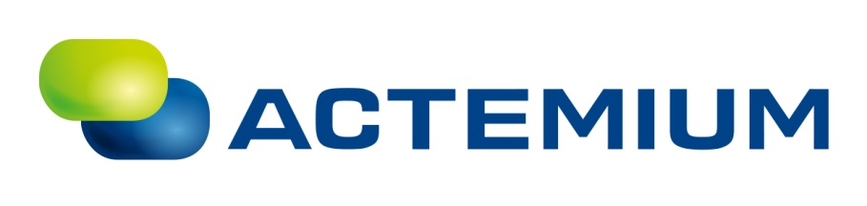

Plan of Approach

The Chocolate Factory, Veghel

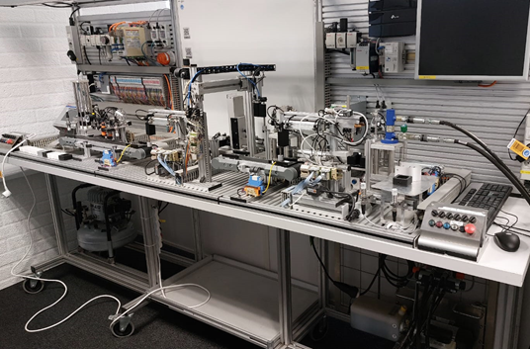

Author(s)
Anastasiia POLIMASHEVA

Revision
0000, 09-APR-2025

General
Project name | : | Bosch Rexroth Mini Factory
Reference Actemium | :
Reference Customer | :
Reference End User | :
Customer | : | The Chocolate Factory
Address | : | Verlengde Noordkade 14 5462 EC Veghel
Postal address | : | PO Box
Telephone | : | 06 57704588
Contact | : | Bart Coppes (bart.c@thechocolatefactory.nl)
End User | : | The Chocolate Factory
Address | : | Verlengde Noordkade 14 5462 EC Veghel
Postal address | : | PO Box
Telephone | : | 06 57704588
Contact | : | Bart Coppes (bart.c@thechocolatefactory.nl)
Contractor | : | PSZO BV
Address | : | Poort van Veghel 4940 5466 SB Veghel
Postal address | : | PO Box 248 5460 AE Veghel
Telephone | : | +31 88 831 89 99
Contact | : | Anastasiia POLIMASHEVA (nastiapolimasheva@gmail.com)

Approval

Actemium | Name | Function | Signature / Date
Written by | Anastasiia POLIMASHEVA
Approved by

Customer | Name | Function | Signature / Date
Approved by
Approved by
Authorized by

End User | Name | Function | Signature / Date
Approved by
Approved by
Authorized by

Distribution List

Revision | Date | To | Company

Document History

Revision | Date | Details | Author
0000 | 09/04/2025 | First draft of PoA | Anastasiia Polimasheva

Table of Contents

General 3
Approval 4
Distribution List 4
Document History 5
Table of Contents 6
References 7
1 Introduction 8
2 Project Definition 9
3 Project Phasing and Control factors 13
4 Planning 15
5 Project Risks 17
Appendix A: Fontys V-Model 19
Appendix B: Explanation of the MoSCoW Prioritization Method 22
Appendix C: FMEA Table Format for Project Risk Evaluation 24

Introduction
The Bosch Rexroth Mini Factory is a fully automated production system designed to simulate real-world industrial processes. Located within The Chocolate Factory in Veghel, this interactive museum and educational center provides visitors—especially children—with hands-on experiences in automation and technology. Actemium, a global industrial solutions provider specializing in automation, system integration, and process optimization, is committed to enhancing interactive learning experiences. This project is an extension of that commitment, aiming to transform the Mini Factory into a user-friendly, educational tool for children aged eight and above.
Actemium operates across multiple industries, delivering cutting-edge engineering solutions. With 23 business units and 1,000 professionals in the Netherlands alone, the company focuses on innovation and education within industrial automation. The project is managed within Actemium’s EduLab, a division dedicated to fostering technological education and hands-on learning experiences.
Currently, the Bosch Rexroth Mini Factory is designed primarily for professional and industrial use, lacking features that make it accessible, engaging, and safe for children. The goal of this project is to transform the Mini Factory into an interactive, multi-functional exhibit suitable for different user groups:
- Daily workshop users who require reliable industrial operations.
- Museum visitors and children who need an intuitive and engaging experience.
- Students of varying educational levels, from primary school to advanced learners, who can experiment with programming and automation.
By enhancing the system’s safety, user experience, and educational capabilities, this project aims to bridge the gap between industrial automation and interactive learning. The engineering approach that is used during project development is Fontys V-model (Appendix A).
This Plan of Approach will provide a structured methodology for executing the project. It includes:
- A detailed analysis of the current system and its limitations.
- The proposed hardware and software modifications to enhance interactivity.
- Safety measures to ensure child-friendly operation.
- Implementation of different user modes, including industrial, demo, leisure, and educational programming modes.
- Aesthetic and usability improvements to enhance engagement.
- A roadmap for testing, validation, and documentation.

Project Definition

Project Justification

1.1 Background of the Project

What's the problem?
The Bosch Rexroth Mini Factory, in its current state, is designed for professional and industrial use, making it unsuitable for educational and interactive learning experiences targeted at children. It lacks intuitive controls, educational programming capabilities, and a structured user experience that accommodates different skill levels.

Why is it a problem?
Without necessary modifications, the Mini Factory remains inaccessible to a broad audience, particularly younger users. This limits its potential as an educational tool, reducing engagement and failing to meet the growing need for STEM (Science, Technology, Engineering, and Mathematics) education through interactive exhibits.

When and in what situations does the problem occur?
- When children and museum visitors attempt to interact with the Mini Factory, they face difficulties due to its industrial design and lack of intuitive controls.
- When educators and workshop facilitators try to incorporate the system into learning activities, they struggle with limited educational programming interfaces.
- When the factory operates in a public space, safety concerns arise due to the complexity of industrial components.

What are the consequences of the problem?
- Limited Engagement: The current system fails to attract and retain the interest of young learners.
- Missed Educational Opportunities: Without interactive learning modes, the factory does not fulfill its potential as a STEM education tool.
- Safety Concerns: Without child-proof modifications, there are risks associated with allowing younger users to engage with the system.
- Underutilization: The Mini Factory is not being fully leveraged to serve multiple user groups effectively.

How will the project solve the problem?
This project will address these challenges by:
- Implementing child-friendly interaction features, including physical controls (buttons, levers, and joysticks) and digital programming interfaces (Scratch and Python).
- Designing a multi-functional operational structure that supports different modes such as Demo Mode, Leisure Mode, and Learning Mode.
- Ensuring the system meets safety standards for children aged 8+.
- Enhancing the visual and interactive appeal of the factory to encourage engagement and learning.

1.2 Problem Description

Concrete Problems in the Existing Situation:
- Lack of Intuitive User Interfaces: The current system is built for industrial use and does not provide a user-friendly interface for children and casual visitors.
- Limited Educational Programming: There is no built-in programming environment that allows students to interact with and control the system in an accessible way.
- Safety Concerns: The existing system is not designed for young users, making it potentially unsafe in a public museum environment.
- Absence of Engaging Interactive Features: Without engaging elements, younger users may struggle to stay interested, reducing the educational impact of the system.
- One-Mode Operation: The Mini Factory currently lacks different operation modes tailored to diverse audiences, limiting its usability across various groups.

1.3 The Assignment
This project will focus on solving the following key problems from Section 1.2:
- Lack of intuitive user interfaces by developing physical controls (buttons, levers, joysticks) and digital programming environments (Scratch and Python).
- Limited educational programming by integrating beginner-friendly and advanced coding capabilities.
- Safety concerns by implementing child-friendly safety mechanisms and compliance with relevant safety guidelines.
- Absence of engaging interactive features by improving the visual and functional design of the Mini Factory.
- One-mode operation by implementing multiple user modes, making the system adaptable to different audiences.

1.4 Project Result
At the end of the project, the following deliverables will be provided to Actemium:
- A fully operational Mini Factory with child-friendly interactive features.
- Physical and digital control systems (buttons, levers, joysticks, and a programming interface in Scratch and JavaScript (maybe other programming languages based on resource and time limits)).
- Multiple operation modes (Demo Mode, Leisure Mode, Learning Modes 1 & 2).
- Enhanced safety mechanisms ensuring compliance with child-safety standards.
- Aesthetic and UX improvements making the factory engaging and visually appealing.
- Comprehensive documentation, including:
  - A user manual.
  - Testing and validation report.
  - Engineering design files and schematics.

1.5 User Requirements (UR)
This section outlines the specific user requirements and project boundaries that are taken from user story and client's wishes (Table 1.5.1). All the user requirements will be graded according to the MoSCoW model priority system evaluation and can be seen by the color code (red - Must; orange - Should, yellow - Could and blue - Won`t) or third column on each user requirements table, where M refers to Must, S refers to Should, C refers to Could and W - to Won`t (see Appendix B).

Table 1.5.1. User requirements graded using MoSCoW
Num. | Description | MoSCoW
UR1 | Execution of the project must align with safety standards of Actemium and The Chocolate Factory | M
UR2 | Safety compliance for children aged 8+ | M
UR3 | Interactive user controls (buttons, touchscreens, joysticks) | M
UR4 | Scratch-based programming interface for beginners | M
UR5 | JavaScript programming capabilities for advanced users | M
UR6 | Multiple operational modes (industrial, demo, leisure, educational) | M
UR7 | Comprehensive user manual or/and instructions on exposition on how-to-use a system | M
UR8 | Appealing design integrated with exposition and user story | M
UR9 | User-friendly visual interface and improved aesthetics | M
UR10 | All additional components should be easy to design within facilities of Chocolate Factory or/and Actemium. Purchase of other components should be discussed and approved by the client | M
UR11 | Intuitive step-by-step tutorials integrated into the system | S
UR12 | Gamification elements to enhance engagement | S
UR13 | Real-time feedback mechanisms for users | S
UR14 | Multi-language support for educational materials | S
UR15 | Option for integration or Integration with external educational platforms | C
UR16 | Mobile application support for remote interaction | C
UR17 | Monitoring system of general users activity for a general management system | C
UR18 | Additional physical interaction components (e.g., haptic feedback devices) | C
UR19 | Additional support of other programing languages for educational use | C
UR20 | Full redesign of existing mechanical hardware beyond minor modifications | W
UR21 | Development of entirely new hardware components | W
UR22 | Expansion beyond the current location of The Chocolate Factory | W
UR23 | Integration with advanced industrial automation tools not suited for educational purposes | W

1.6. Project Boundaries
This project focuses on improving the educational and interactive aspects of the Mini Factory while maintaining its industrial training functionality. The following aspects are out of scope:
- Redesigning the complete mechanical system.
- Developing new industrial automation processes beyond educational interactions.
- Implementing VR/AR solutions.
- Creating a fully autonomous AI-driven operation.
- Conducting large-scale user studies beyond test groups.

Project Phasing and Control factors
Phase 1: Research & Concept Development Duration: 27/03/2025 - 15/04/2025 (3 weeks)
- Activities:
  - Conduct background research on similar projects and existing solutions.
  - Identify challenges faced by children that the project aims to address.
  - Develop the "Story of Production" for an engaging experience.
  - Define the overall system architecture (mechanical, electrical, software, pneumatic, hydraulic components).
  - Create overview and documentation for already created product
- Deliverables:
  - Research report summarizing findings.
  - Defined user scenarios and production story.
  - Initial conceptual sketches.
  - Documentation and overview for existing system
- Control Factors:
  - Time: 3-week timeframe.
  - Organization: Involves project members, industry advisors, and stakeholders.
  - Information: Literature review, interviews, and brainstorming sessions.
  - Quality: Validate findings through expert reviews.
  - Money: Minimal costs for research materials and consultation.

Phase 2: System Design & Documentation Duration: 16/04/2025 - 10/05/2025 (3.5 weeks)
- Activities:
  - Develop schematics for electrical, pneumatic, mechanical, and hydraulic systems.
  - Develop components
  - Define software architecture and interfaces.
  - Perform safety evaluation and determine necessary precautions.
- Deliverables:
  - CAD models of mechanical structures.
  - Circuit diagrams and wiring layouts.
  - Pneumatic and hydraulic schematics.
  - Software flowcharts and system architecture.
  - Safety evaluation report.
  - Ordering necessary components
- Control Factors:
  - Time: Strict timeline to ensure testing can begin as scheduled.
  - Organization: Collaboration between engineers, designers, and safety experts.
  - Information: Compliance with industry standards and safety regulations.
  - Quality: Peer-reviewed documentation and adherence to standards.
  - Money: Approx. €500 for software, tools, and design resources.

Phase 3: Prototyping & Initial Testing Duration: 11/05/2025 - 05/06/2025 (3.5 weeks)
- Activities:
  - Develop physical prototypes of mechanical components.
  - Assemble and integrate electrical, pneumatic, and hydraulic systems.
  - Implement initial software functionality and test integration.
  - Safety testing and validation.
- Deliverables:
  - Fully assembled prototype.
  - Functional testing report.
  - Safety compliance verification.
- Control Factors:
  - Time: Ensure the prototype is functional before final testing.
  - Organization: Engineers, technicians, and external consultants.
  - Information: Test plans, technical specifications.
  - Quality: Ensure prototypes meet functional and safety requirements.
  - Money: Approx. €1,000 for prototype materials and testing equipment.

Phase 4: System Integration & Refinement Duration: 06/06/2025 - 20/06/2025 (2 weeks)
- Activities:
  - Integrate refined subsystems into a final prototype.
  - Perform full-scale system testing and troubleshooting.
  - Conduct stakeholder reviews and implement feedback.
- Deliverables:
  - Refined system with improved functionality.
  - Finalized technical documentation.
  - System performance evaluation report.
- Control Factors:
  - Time: Two weeks to finalize and optimize.
  - Organization: Lead engineers, designers, and client.
  - Information: Final testing reports, safety documentation.
  - Quality: System performance benchmarks and final user validation.
  - Money: Approx. €800 for final refinements and testing tools.

Phase 5: Final Testing & Project Closure Duration: 21/06/2025 - 01/07/2025 (1.5 weeks)
- Activities:
  - Perform comprehensive functional, safety, and usability testing.
  - Prepare final documentation for client handover.
  - Present project outcomes and receive approval.
- Deliverables:
  - Complete project documentation.
  - Final presentation and approval from stakeholders.
  - User manual and maintenance guide.
- Control Factors:
  - Time: Strict deadline for closure.
  - Organization: Project team and client.
  - Information: Finalized documentation, reports.
  - Quality: Validation against user requirements and safety norms.
  - Money: €500 for final documentation and presentation resources.
Buffer time: 15 days
Total Project Duration: 27/03/2025 - 15/07/2025

Planning
Due to the fact that the project involves collaboration and communication between different parties, a flexible project schedule is necessary to adjust to the availability of each of the project members. For this reason planning is divided into weeks, instead of weeks, and includes 15 days of buffer time for any unforeseen delays. Planning can be seen in the Table. 3.1.

Table 3.1. Planning of the project
Week 1 | 27 Mar – 2 Apr | Project Kickoff & Planning  - Finalize project scope and deliverables  - Team role assignments  - Initial meetings with stakeholders  - Define project methodologies
Week 2 | 3 Apr – 9 Apr | Research & Initial Documentation  - Research educational robotics and child learning challenges  - Define key production challenges  - Start defining system requirements
Week 3 | 10 Apr – 16 Apr | User Requirements & Functional Specs  - Finalize user requirements using MoSCoW method  - Develop functional specifications for software, mechanical, and electrical systems  - Validate requirements with stakeholders
Week 4 | 17 Apr – 23 Apr | System Architecture & Concept Development  - Develop initial mechanical/electrical/software architecture  - Create high-level system schematics  - Define preliminary safety considerations
Week 5 | 24 Apr – 30 Apr | Concept Validation & Approval  - Review concepts with team and stakeholders  - Adjust system architecture based on feedback  - Finalize materials and component selection
Week 6 | 1 May – 7 May | Detailed Design: Mechanical & Electrical  - Start detailed CAD modeling for mechanical design  - Develop electrical schematics  - Define pneumatics/hydraulics integration
Week 7 | 8 May – 14 May | Detailed Design: Software & Control Systems  - Develop software architecture  - Define control logic and interfaces  - Integrate safety features into design
Week 8 | 15 May – 21 May | Prototype Development & Documentation  - Manufacture first mechanical components  - Assemble electrical control systems  - Develop first version of software
Week 9 | 22 May – 28 May | Subsystem Testing & Iteration  - Test mechanical components for durability  - Verify electrical circuit functionality  - Validate software responsiveness
Week 10 | 29 May – 4 Jun | Integration & System Testing  - Assemble mechanical, electrical, and software components  - Conduct integration tests  - Document findings and improvements
Week 11 | 5 Jun –  11 Jun | Final System Refinements  - Apply feedback from integration tests  - Final safety evaluation and implementation  - Perform final hardware adjustments
Week 12 | 12 Jun – 18 Jun | Final Testing & User Acceptance  - Conduct final system-wide tests  - Validate system performance against requirements  - Stakeholder review and approval
Week 13 | 19 Jun – 25 Jun | Final Documentation & Training  - Complete technical documentation (schematics, manuals)  - Conduct team training on the system  - Prepare final project presentation
Week 14 | 26 Jun –  1 Jul | Project Handover & Closure  - Deliver final product to the client  - Conduct project review and lessons learned session  - Close all project documentation

Project Risks
This section focuses on evaluation project risks using FMEA evaluation method (Appendix C). Table 5.1 is arranged in the way that the second column refers to Impact, third - to Probability, forth to the Vulnerability and fifth column is Risk Priority (Impact x Probability x Vulnerability). These FMEA tables are mainly for general project evaluation purposes, during development of the system FMEA table for each part of the project is going to be extended.

Table 5.1 FMEA Risk Assessment
Risk | I | P | V | R | Mitigation Action
Poor communication between teams | High | Medium | Medium | High x Medium x Medium = High | Schedule regular progress meetings, use shared project management tools, and maintain open communication channels.
Lack of skilled personnel or key team members being unavailable | High | Medium | High | High x Medium x High = High | Ensure knowledge sharing within the team and cross-train members to cover essential roles.
Scope creep leading to delays and budget overruns | High | Medium | High | High x Medium x High = High | Clearly define project boundaries and implement a change control process to evaluate additional requirements.
Accepting unrealistic deadlines | High | Low | Medium | High x Low x Medium = Medium | Conduct detailed project planning to assess feasibility before committing to timelines.
Incomplete project schedule leading to missed deadlines | High | Medium | Medium | High x Medium x Medium = High | Develop a comprehensive and detailed project timeline with milestones and regular progress tracking.
Lack of mentorship | High | Medium | High | High x Medium x High = High | Establish mentorship programs within the team and assign experienced team members to guide less experienced ones.
Materials delivery delays | High | Medium | High | High x Medium x High = High | Maintain strong relationships with suppliers, have backup suppliers, and plan orders well in advance.
Improper responsibility share | Medium | High | Medium | Medium x High x Medium = Medium | Clearly define roles and responsibilities within the team and ensure accountability through regular check-ins.
Lack of leadership | High | Medium | High | High x Medium x High = High | Assign a strong project leader, provide leadership training if necessary, and ensure clear decision-making structures.

Appendix A: Fontys V-Model
The V-Model is a graphical representation of the development process that emphasizes the importance of verification and validation at each stage of a project. It is called the "V-Model" because of its shape, where the left side represents the phases of development and the right side represents the corresponding phases of testing and validation.

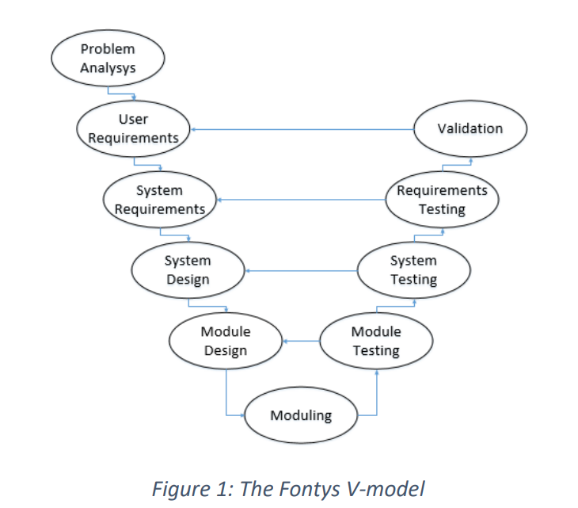

Figure A.1 Fontys V-model
The Fontys V-Model consists of several phases that follow a sequential flow (Figure A.1). However, it also acknowledges the iterative nature of real-world projects where testing and verification activities might take place repeatedly throughout the project lifecycle.

A.1 Left Side: Project Development
The left side of the V represents the development phases of the project. These steps focus on defining and designing the solution.
- Requirement Analysis
  - Objective: Define the needs and requirements of the project.
  - Activities:
    - Gather and analyze all relevant project requirements (technical, functional, and non-functional).
    - Define the scope, objectives, and deliverables of the project.
  - Outcome: A detailed requirements specification document.
- System requirements
  - Objective: Define specific requirements and testing plan
  - Activities:
    - Conduct the research, validate user requirements and translate them into System requirements using SMART system
    - Based on the system requirements, create testing and validation plans
- System Design
  - Objective: Translate the requirements into a design solution.
  - Activities:
    - Design the architecture, components, and workflows of the system.
    - Create high-level and low-level design documentation, including interfaces, algorithms, and technologies.
  - Outcome: System design documents and a prototype (if applicable).
- Module Design
  - Objective: Break down the system design into smaller components.
  - Activities:
    - Design individual modules and their functionalities.
    - Define module-level details
- Outcome: Detailed module-level design documents and mock-ups (if applicable).
- Moduling
  - Objective: Develop the system components.
  - Activities:
    - Create a system based on the design specifications.
    - Implement system functionality, including integration with external systems or platforms.
  - Outcome: Working prototype and functional system components.

A.2 Right Side: Project Validation and Testing
The right side of the V represents the testing and validation phases, where each development step is verified to ensure the solution meets the requirements and works as expected.
- Module Testing
  - Objective: Verify the correctness of individual modules or components.
  - Activities:
    - Test individual functions or classes in isolation.
    - Ensure that each module meets its specifications.
  - Outcome: Reports on subsystem tests, including successful and failed tests.
- System Testing
  - Objective: Ensure the system works as a whole.
  - Activities:
    - Test the full system in an environment similar to the production environment.
    - Verify the system functionality against the original requirements.
  - Outcome: Comprehensive testing results, verifying that the system meets the overall specifications.
- Acceptance Testing
  - Objective: Confirm that the system meets the user or stakeholder's needs.
  - Activities:
    - Perform tests to validate that the system meets business requirements and user expectations.
    - Engage stakeholders or end-users to confirm that the system is ready for deployment.
  - Outcome: User acceptance tests, sign-off from stakeholders, and preparation for deployment.

Benefits of the Fontys V-Model
- Clear Structure: The V-Model provides a clear, step-by-step approach to project development, which is easy to understand and follow.
- Early Detection of Issues: With built-in testing and validation, problems are identified and resolved early in the project lifecycle.
- Traceability: Each phase of development is closely tied to testing, ensuring that the final system aligns with the original requirements.
- Documentation: The model emphasizes comprehensive documentation at each stage, making it easier for project members and stakeholders to understand the project’s progress.

Appendix B: Explanation of the MoSCoW Prioritization Method
The MoSCoW method is a prioritization framework used in project management to classify requirements based on their importance and urgency (Figure B.1).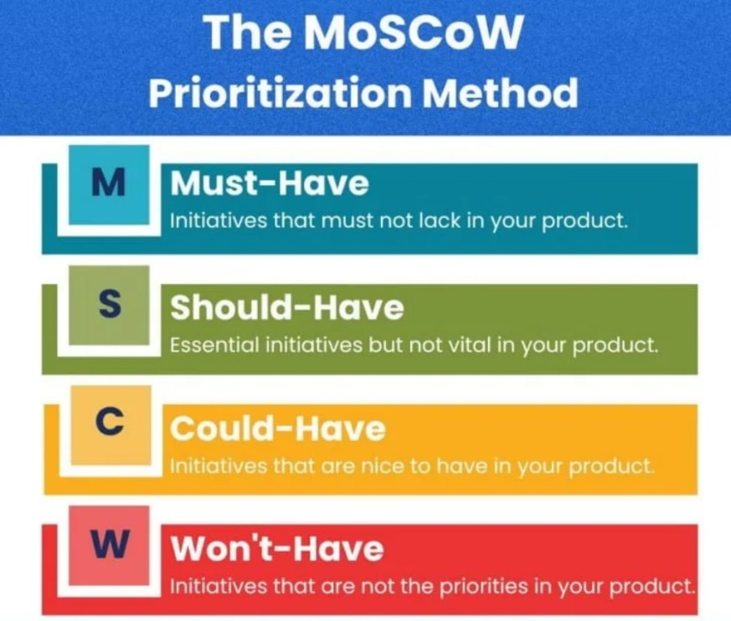
Figure B.1. MoSCoW prioritization method visualization

The acronym "MoSCoW" stands for:
- M – Must Have
These are the core requirements that are critical for the project’s success. Without these requirements, the system or solution will fail to function as intended. "Must Have" requirements are non-negotiable and must be delivered within the scope and timeline of the project.
Examples of "Must Have" requirements:
  - Basic functionality necessary for the system to operate.
  - Features required to meet regulatory or safety standards.
- S – Should Have
These requirements are important but not absolutely essential. While the project can still succeed without them, their absence may reduce efficiency, usability, or user satisfaction. "Should Have" requirements are typically prioritized after all "Must Have" requirements are met.
Examples of "Should Have" requirements:
  - Additional features that enhance the user experience.
  - Improvements that make the system more scalable or flexible.
- C – Could Have
These requirements are desirable but not critical. They are considered "nice-to-have" features that add value to the project but can be omitted if time, budget, or resources are limited. "Could Have" requirements are often the first to be deprioritized when constraints arise.
Examples of "Could Have" requirements:
  - Minor cosmetic enhancements.
  - Features that offer convenience but do not affect core functionality.
- W – Won’t Have (This Time)
These requirements are acknowledged but explicitly excluded from the current project scope. They may be revisited in future phases or projects. Categorizing requirements as "Won’t Have" ensures clear communication with stakeholders about what will not be delivered.
Examples of "Won’t Have" requirements:
  - Advanced features that exceed the current budget or timeline.
  - Capabilities not aligned with the immediate objectives of the project.

Benefits of Using the MoSCoW Method
The MoSCoW method helps stakeholders and project teams:
- Prioritize effectively by distinguishing between critical and optional requirements.
- Align expectations by clearly defining what will and will not be delivered.
- Manage resources by focusing on delivering the most important features within constraints.
- Adapt flexibly by allowing trade-offs between "Should Have" and "Could Have" requirements when necessary.

Appendix C: FMEA Table Format for Project Risk Evaluation
An FMEA (Failure Mode and Effect Analysis) table is used to systematically evaluate potential risks associated with your project. The main goal is to identify potential failures (risks), assess their potential impacts, their probability, and vulnerability, and then assign a Risk Priority Number (RPN) to help prioritize the most critical risks.
Below is the breakdown of the FMEA (Table C.1):

Table C.1. FMEA table components for risk evaluation
Column | Explanation
Risk | The identified risk or failure mode (e.g., mechanical failure, delays, compatibility issues).
Impact | The severity of the potential consequence of the risk on the project (e.g., high, medium, low).
Probability | The likelihood of the risk occurring (e.g., high, medium, low).
Risk Degree | The initial risk evaluation, calculated as the Impact x Probability. It helps in understanding how significant the risk is.
Vulnerability | The project’s susceptibility to damage or failure in the event the risk occurs. It helps in determining how much the risk can be absorbed by the project.
Risk Priority (Risk x Probability x Vulnerability) | The final risk evaluation using the formula Risk Priority = Impact x Probability x Vulnerability. It allows prioritizing risks.
Mitigation Action | The actions planned or taken to reduce or eliminate the identified risk.

FMEA Scoring Criteria
The Impact, Probability, and Vulnerability are rated using the same scoring criteria to ensure consistency across the project.
- Low: Minimal impact, very low probability, or low vulnerability.
- Medium: Moderate impact, moderate probability, or moderate vulnerability.
- High: Severe impact, very high probability, or high vulnerability.
Once the Impact (I), Probability (P), and Vulnerability (V) are assigned, the Risk Priority Number (RPN) is calculated using the formula:
RPN = Impact (I) × Probability (P) × Vulnerability (V)

Document Revision The following revision numbering is applied to this document: Revision (or Rev.): GGRR For new project documents, the revision number is 0000. Revisions for approval, the revision number is GGRR in which GG = 00 to 99 and RR = 01 to 99. Approved revisions, the revision number is GG00 in which GG = 01 to 99.

